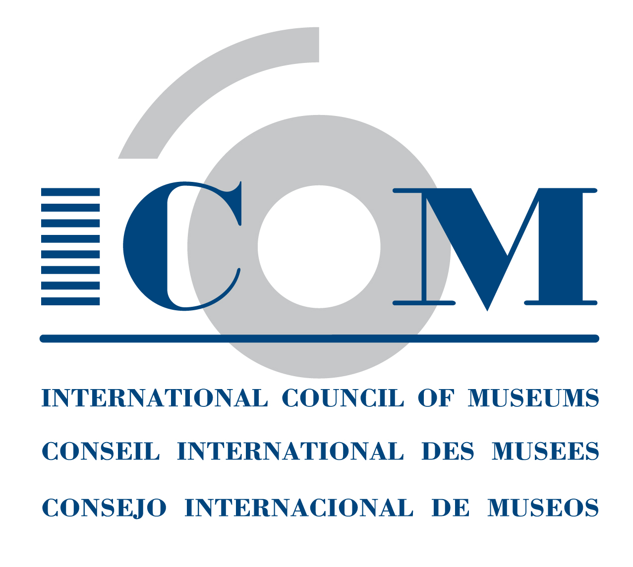 | APPLICATION FORM  INTERNATIONAL COMMITTEE MEMBERSHIP  FOR INVIDIDUAL MEMBERS  ICOM Secretariat  Maison de l'UNESCO - 1, rue Miollis - 75732 Paris Cedex 15 - France  Tel: + 33 (0) 1 47 34 05 00 Fax: + 33 (0) 1 43 06 05 54  Email: membership@icom.museum Website: http://icom.museum

BENEFIT OF YOUR MEMBERSHIP: JOIN AN ICOM INTERNATIONAL COMMITTEE!
If you are individual or institutional members of ICOM, your ICOM membership allows membership in one or more of ICOM’s 31 International Committees, which represent different types of collections and museum professions.
By joining an International Committee:
- You will receive up-to-date news about the profession and have access to publications and newsletters.
- You may participate in their annual meetings and other activities in different parts of the world, benefitting from preferential rates.
- You can keep up with the discussion among professionals within the International Committee online.
- You can take part in joint activities organised with other ICOM International Committees, organisations and institutions.
- You can specialise yourself by joining the special interest or working groups of some International Committees.

INDIVIDUAL MEMBERS
If you have not yet joined any International Committee or if you wish to change your International Committee, take the opportunity to choose among the following 31 International Committees:
- one (1) in which you have full voting rights (except members in “students” and “supporting” categories):
- up to three (3) in which you are interested in order to receive information from them:

Archaeology & History (ICMAH)
Architecture & Museum Techniques (ICAMT)
Arms & Military History (ICOMAM)
Audio-visual & New Technologies (AVICOM)
Conservation (ICOM-CC)
Decorative Arts and Design (ICDAD)
Collecting (COMCOL)
Costume
Documentation (CIDOC)
Education & Cultural Action (CECA)
Egyptology (CIPEG)
Ethnography (ICME)
Exhibition Exchange (ICEE)
Fine Arts (ICFA)
Glass
Historic House Museums (DEMHIST)
Literary Museums (ICLM)
Management (INTERCOM)
Marketing & Public Relations (MPR)
Memorial Museums (IC MEMO)
Modern Art (CIMAM)
Money & Banking Museums (ICOMON)
Museology (ICOFOM)
Museum Security (ICMS)
Museums of Cities (CAMOC)
Musical Instruments (CIMCIM)
Natural History (NATHIST)
Regional Museums (ICR)
Science & Technology (CIMUSET)
Training of Personnel (ICTOP)
University Museums (UMAC)

For further details on each of the International Committees, please consult the ICOM website -> Who we are -> The Committees -> International Committees.
First name: | Last name:
ICOM card number (if you already have one):
Date: | Signature:

If you apply for the International Committee membership at the same time of your ICOM membership, please submit this form together with your ICOM membership application form to your National Committee.
If you are already an ICOM member and wish to apply for or modify your International Committee membership, please submit this form directly to ICOM Secretariat (Fax: +33 (0)1 43 06 05 54; Email: membership@icom.museum)

INSTITUTIONAL MEMBERS
Institutions can appoint representatives as voting members for International Committees. The same representative can be appointed to three different International Committees or three different representatives can be appointed to one of up to three International Committees. These representatives may also choose to receive information, without being voting members, from up to three (3) International Committees. If you wish to find out more about this opportunity and benefit from memberships to International Committees, please contact the ICOM Secretariat (tito.chan@icom.museum).

